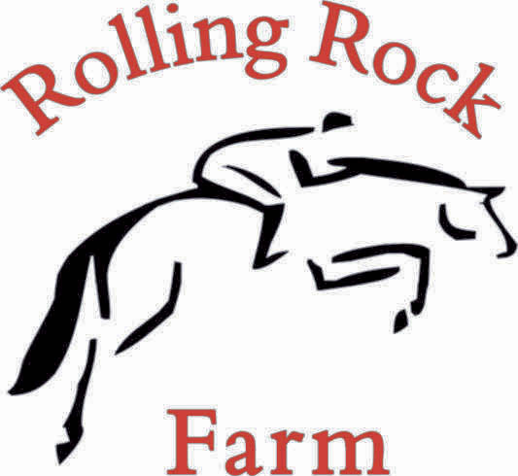

24949 SW Baker Rd Sherwood, Or 97139

2026 All Breed Summer Show Series

Show starts at 8am

June 6th July 11th August 29th

Judges: Emily Honey Angie Vachter Torry Brooks

- Halter 2 yrs & Under
- Halter 3 yrs & Over
- Halter Geldings
- Halter Mares
- Halter Ponies & Minis
- Halter Championship (1st & 2nd place winners of classes 1-4 – no entry fee)

- Showmanship 10 & Under
- Showmanship 13 & Under
- Showmanship 14-17
- Showmanship 18-38
- Showmanship 39 & Over

- English W/T 39 & Over
- English W/T 18-38
- English W/T 14-17
- English W/T 13 & Under
- English W/T 10 & Under
- English W/T – Stock Horse
- English W/T – Saddle Type Horse
- English W/T – Green Rider
- English W/T – Green Horse

- English Pleasure 39 & Over
- English Pleasure 18-38
- English Pleasure 14-17
- English Pleasure 13 & Under
- English Pleasure – Stock Horse
- English Pleasure – Saddle Type Horse
- English Pleasure – Novice Horse
- English Pleasure – Novice Rider
- English Pleasure – Green Horse

- English Equitation 39 & Over
- English Equitation 18-38
- English Equitation 14-17
- English Equitation 13 & Under
- English Equitation – Novice Rider
- English Equitation – Green Rider

Break

- Western W/T 39 & Over
- Western W/T 18-38
- Western W/T 14-17
- Western W/T 13 & Under
- Western W/T 10 & Under
- Western W/T – Stock Horse
- Western W/T – Saddle Type Horse
- Western W/T – Green Rider
- Western W/T – Green Horse

- Western Pleasure 39 & Over
- Western Pleasure 18-38
- Western Pleasure 14-17
- Western Pleasure 13 & Under
- Western Pleasure – Stock Horse
- Western Pleasure – Saddle Type Horse
- Western Pleasure – Novice Horse
- Western Pleasure – Novice Rider
- Western Pleasure – Green Horse

- Western Equitation 39 & Over
- Western Equitation 18-38
- Western Equitation 14-17
- Western Equitation 13 & Under
- Western Equitation – Novice Rider
- Western Equitation – Green Rider

High Point Series Award Buckles for English & Western:

10 & Under*, 13 & Under, 14-17, 18-38, 39 & Over, Novice Horse, Novice Rider,

Green Horse, Green Rider, Stock Horse, Saddle Type Horse

*No cross entry into 13 & Under

Green Horse/Rider – First Year of showing

Novice Horse/Rider – Never won 3 blue ribbons

