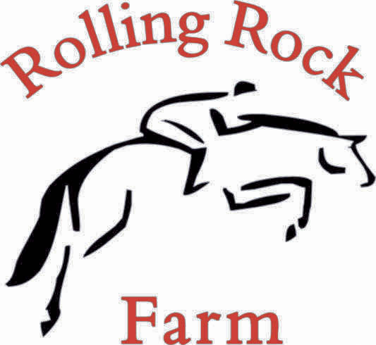

2026 Horse Show Series

OUTDOOR ARENA – 9:30 am Jumpers

Saturday Sunday
1A 1B Cross Rail Jumpers .30m (12”)
2A 2B Cross Rail Jumpers .30m (12”)
3A 3B Cross Rail Jumpers .30m (12”)

4A 4B Beginner Jumpers .45m (18”) - Table II, 2(b) - Jump Off
5A 5B Beginner Jumpers .45m (18”) - Table II, 2(b) - Jump Off
6A 6B Beginner Jumpers .45m (18”) - Table II, Sec 1 - Speed Round

7A 7B Jumper .60-.65m (2’) - Table II, 2(b) - Jump Off
8A 8B Jumper .60-.65m (2’) - Table II, 2(b) - Jump Off
9A 9B Jumper .60-.65m (2’) - Table II, Sec 1 - Speed Round

10A 10B Jumper .70-.75m (2’3”) - Table II, 2(b) - Jump Off
11A 11B Jumper .70-.75m (2’3”) - Table II, 2(b) - Jump Off
12A 12B Jumper .70-.75m (2’3”) - Table II, Sec 1 – Speed Round

13A 13B Jumper .80m (2’6”) - Table II, 2(b) - Jump Off
14A 14B Jumper .80m (2’6”) - Table II, 2(b) - Jump Off
15A 15B Jumper .80m (2’6”) - Table II, Sec 1 - Speed Round

16A 16B Jumper .85m (2’9”) - Table II, 2(b) - Jump Off
17A 17B Jumper .85m (2’9”) - Table II, 2(b) - Jump Off
18A 18B Jumper .85m (2’9”) - Table II, Sec 1 – Speed Round

Rolling Rock Farm Show Weekend Jumper Champion/Res Champion awarded for:
Cross rail, .45m, .60-65m, .70-.75m, . 80m, .85m

INDOOR ARENA – 9:00 AM Hunters O/F = Over Fences U/S = Under Saddle

Saturday Sunday

Trot a Pole
19A 19B Trot a Pole Hunter O/F
20A 20B Trot a Pole Hunter O/F
21A 21B Trot a Pole Equitation O/F
22A 22B Trot a Pole Equitation O/F
23A 23B Trot a Pole Hunter U/S - (WT only)
24A 24B Trot a Pole Equitation U/S - (WT only)

25A 25B Leadline

Trot a Cross Rail
26A 26B Trot a Cross Rail Hunter U/S - WTC
27A 27B Trot a Cross Rail Equitation U/S - WTC
28A 28B Trot a Cross Rail Hunter 12” O/F
29A 29B Trot a Cross Rail Hunter 12” O/F
30A 30B Trot a Cross Rail Equitation 12” O/F
31A 31B Trot a Cross Rail Equitation 12” O/F

18” Hunters
32A 32B Hunter 18” O/F
33A 33B Hunter 18” O/F
34A 34B Equitation 18” O/F
35A 35B Equitation 18” O/F
36A 36B Hunter 18” U/S
37A 37B Equitation 18” U/S

2’ Hunters (Short/Long Stirrup)
38A 38B Hunter 2’ U/S
39A 39B Equitation 2’ U/S
40A 40B Hunter 2’ O/F
41A 41B Hunter 2’ O/F
42A 42B Equitation 2’ O/F
43A 43B Equitation 2’ O/F

2’3” Hunters (Short/Long Stirrup)
44A 44B Hunter 2’3” O/F
45A 45B Hunter 2’3” O/F
46A 46B Equitation 2’3” O/F
47A 47B Equitation 2’3” O/F
48A 48B Hunter 2’3” U/S
49A 49B Equitation 2’3” U/S

2’6” Hunters (Low Child/Adult)
50A 50B Hunter 2’6” U/S
51A 51B Equitation 2’6” U/S
52A 52B Hunter 2’6” O/F
53A 53B Hunter 2’6” O/F
54A 54B Equitation 2’6” O/F
55A 55B Equitation 2’6” O/F

Rolling Rock Farm Show Weekend
Hunter/Equitation Champion/Res Champion awarded
For Trot a Pole, Trot a Cross Rail, 18”, 2”, 2’3”, 2’6” Divisions



